FET Change Request Form

Information | Execution Date/Time | 2026/11/05 00:00 –06:00
Information | Objective | 2MB MMS 跨網測試
Information | Detail Description | MM4 extend to 3M  MM7 extend to 3M  Impact node :  None
Information | Change NE (Node) | MMS-MMSC01P/ MMS-MMSC02P / MMS-MMSC03P  MMS-LB01P / MMS-LB02P
Information | Stage 驗證  (是否有Stage驗證, 若無-用取代機制.) | 請用下拉選單選擇 Stage 驗證機制 :  Verify in staging  附註內容 :
Information | SR Number
Information | SR Requester
Information | CR Level | c2
Information | C2以上執行時間例外 | L3同意02:00前執行

- Involved Party & RR Definition (Vendor 一定要有一個 人員為 CR Coordinator )
FET or Vender | Vender Coordinator | Job Definition | Department Name | Name | Mobile Phone Number
FET | 請選擇 | CR executer & testing | NT-NO-VOO-MSO | Wayne Lu | 0955227256
Taifon | Y | CR executer & testing | Engineer | David Xiao | 0973291018

- Implementation Procedure & Time Table(載明執行時間/內容與順序)

Item | Start Time | End  Time | Duration  (min) | Action/Command | Responsible  (廠商/FET + 人員名稱) | Comments
1 | 00:00 | 00:05 | 5 min | Pre Check  Check ems Alarm https://10.76.129.149/cm/  check  MMS-MMSC01P/ MMS-MMSC02P / MMS-MMSC03P  MMS-LB01P / MMS-LB02P  是否有 Alarm (做為CR前後Alarm比對) | FET-Wayne  Taifon -David
2 | 00:05 | 01:05 | 60 min | Pre Backup configuration  Web config with backup | FET-Wayne  Taifon -David
3 | 01:05 | 01:35 | 30 min | Implement  - 登入  https://10.76.129.141/mmsadm/  2 change config  Max_mail_siize=3145728  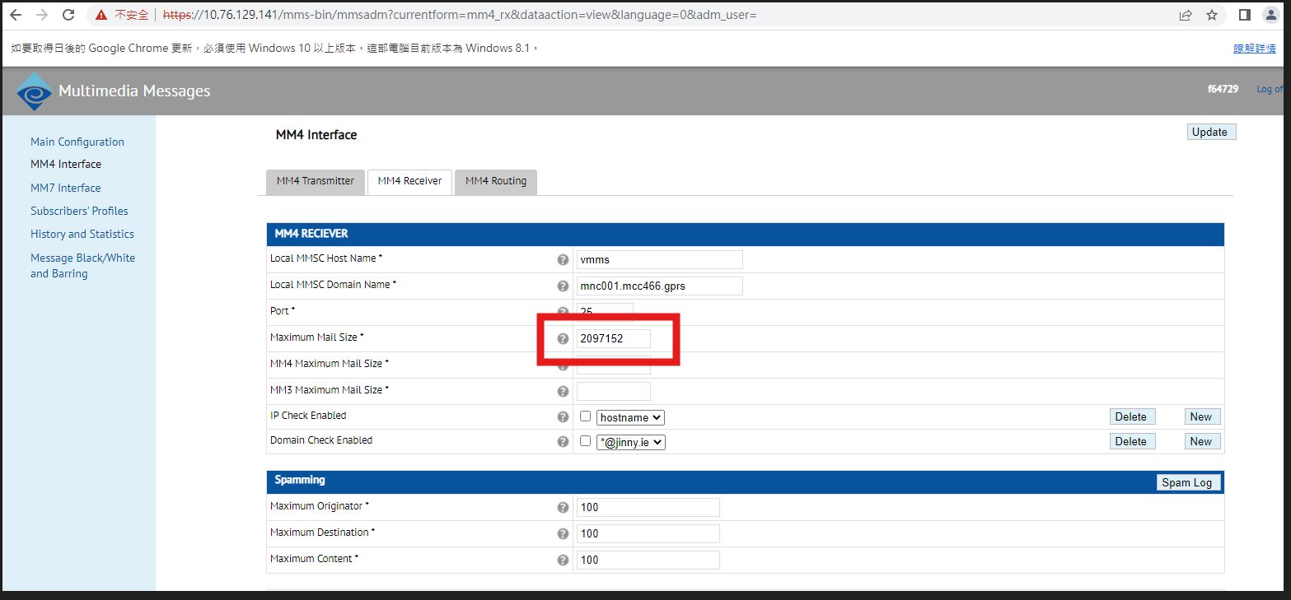  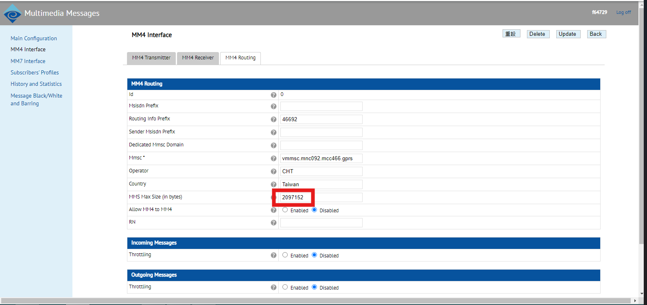  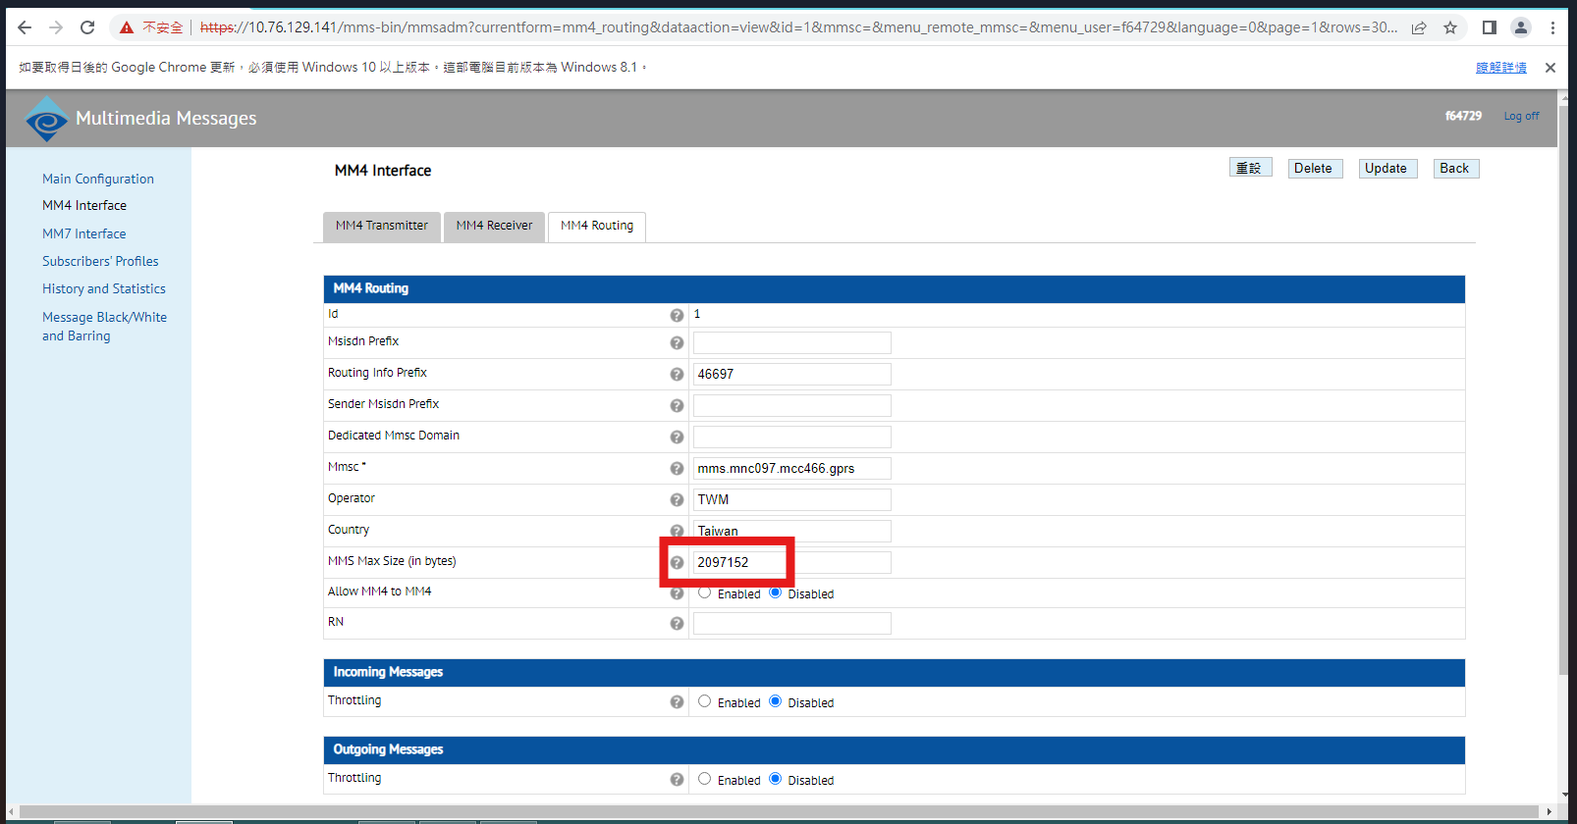  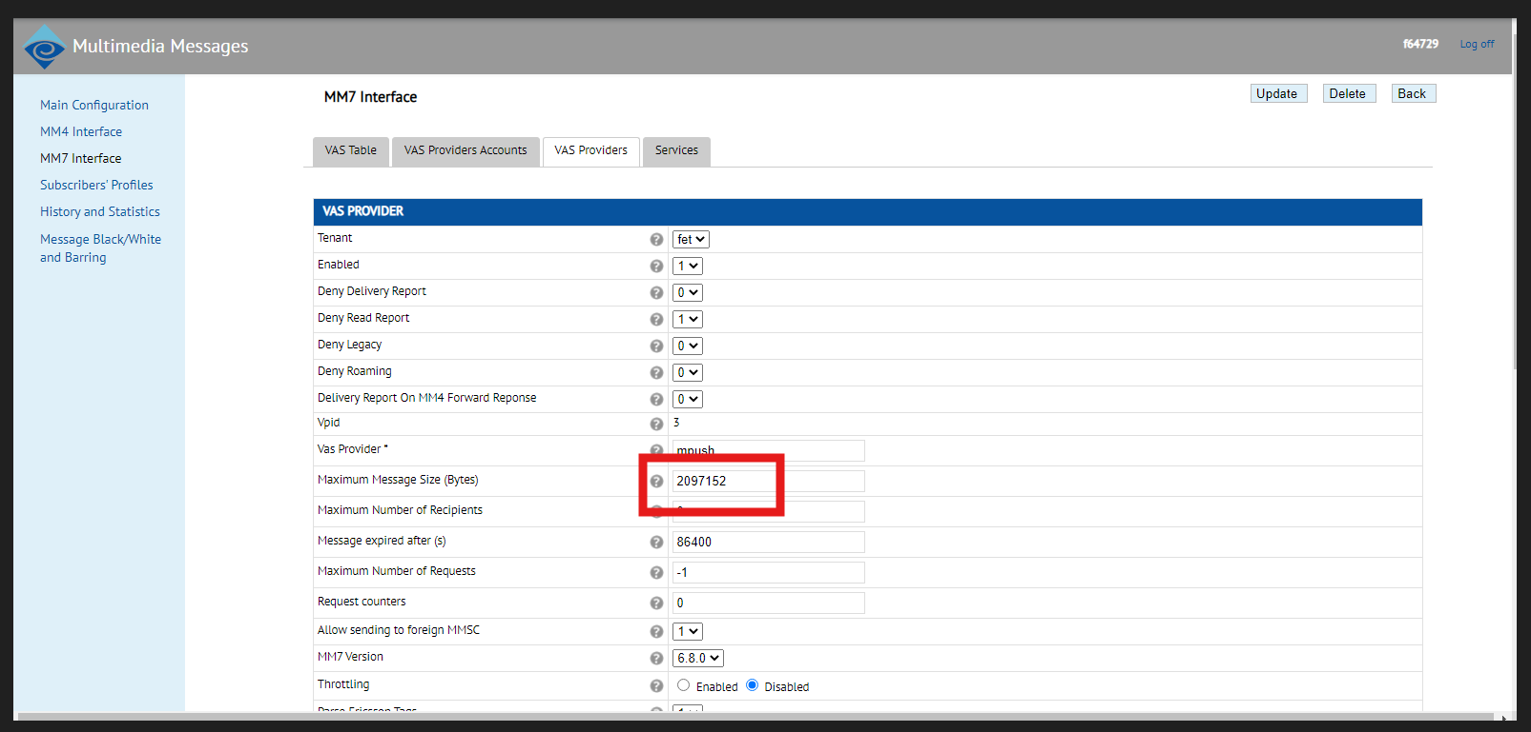 | FET-Wayne  Taifon -David
4 | 01:35 | 02:35 | 60 min | Post Check  N/A | FET-Wayne  Taifon -David
5 | 02:35 | 02:50 | 15 min | Post Backup configuration  Web config with backup | FET-Wayne  Taifon -David
6 | 02:50 | 03:00 | 10 min | Post Health check & KPI check & Regression test  Check ems Alarm https://10.76.129.149/cm/  MMS-MMSC01P/ MMS-MMSC02P / MMS-MMSC03P  MMS-LB01P / MMS-LB02P  是否有 Alarm (做為CR前後Alarm比對) | FET-Wayne  Taifon -David

- Fallback Plan (註明Fallback決定時間 & Fallback Criteria)

Item | Start Time | End  Time | Duration  (min) | Fallback Action/Command | Responsible  (廠商/FET + 人員名稱) | Comments
1 | 04:00 | 04:30 | 30 min | Implement  - 登入  https://10.76.129.141/mmsadm/  2 change config  Max_mail_siize=2097152 | FET-Wayne  Taifon -David
2 | 04:30 | 05:30 | 60 min | Post Check  N/A
3 | 05:30 | 05:40 | 10 min | Post Health check & KPI check & Regression test  Check ems Alarm https://10.76.129.149/cm/  check  MMS-MMSC01P/ MMS-MMSC02P / MMS-MMSC03P  MMS-LB01P / MMS-LB02P  是否有 Alarm (做為CR前後Alarm比對)  是否有 Alarm (做為CR前後Alarm比對) | FET-Wayne  Taifon -David

- 監控機制 : System Health check /KPI Check/ regression call test (詳細 Test case) ( 做為CR 前 與 CR 後 之 KPI & 服務功能不受影響 之確認) - 請附 KPI 監控機制 , Health check and Regression test 之 說明
System Health check

KPI Check

regression call test
- Function SIT/UAT (測試項目過多時可以附件夾檔於文件中)
- Capacity and Utilization Check before/after CR (e.g. route utilization from 60% to 90%)
- Service Impact Identify & Risk Analysis
- Plan B If CR executed must be success, please fill in alternative solution when CR failure
- Baby Sitting Monitoring Criteria
- 風險評估表
影響程度
高度(3) | 高度(6) | 極度(9)
中度(2) | 高度(4) | 高度(6)
低度(1) | 中度(2) | 高度(3)
非常嚴重(3)
嚴重(2)
輕微(1)

幾乎不可能(1) 可能(2) 幾乎確定(3)
發生機率
- Appendix Files

